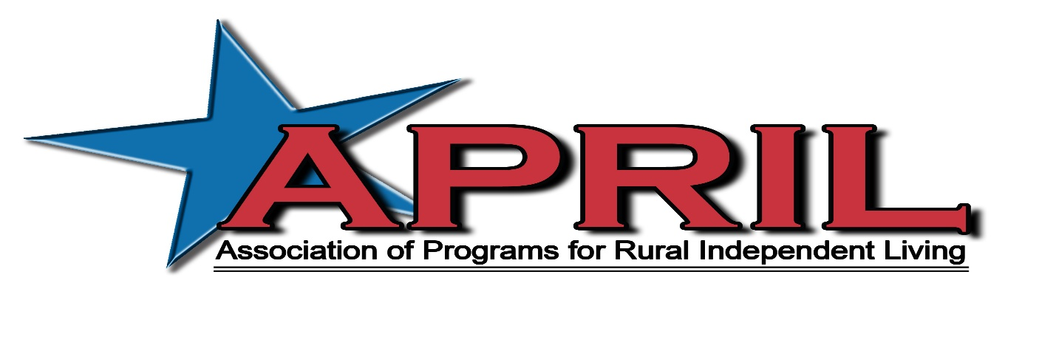
At a Glance 2018

The Association of Programs for Rural Independent Living (APRIL) is a national grassroots, nonprofit membership organization consisting of over 260 members from Centers for Independent Living, their satellites and branch offices, Statewide Independent Living Councils, Youth Leadership Forums, and other organizations and individuals concerned with the independent living issues of people with disabilities living in rural America. APRIL was founded in 1986 by twelve directors of rural CILs at a meeting in Houston, Texas. In 1994, APRIL attained its 501(C)(3) status and hired a national coordinator.

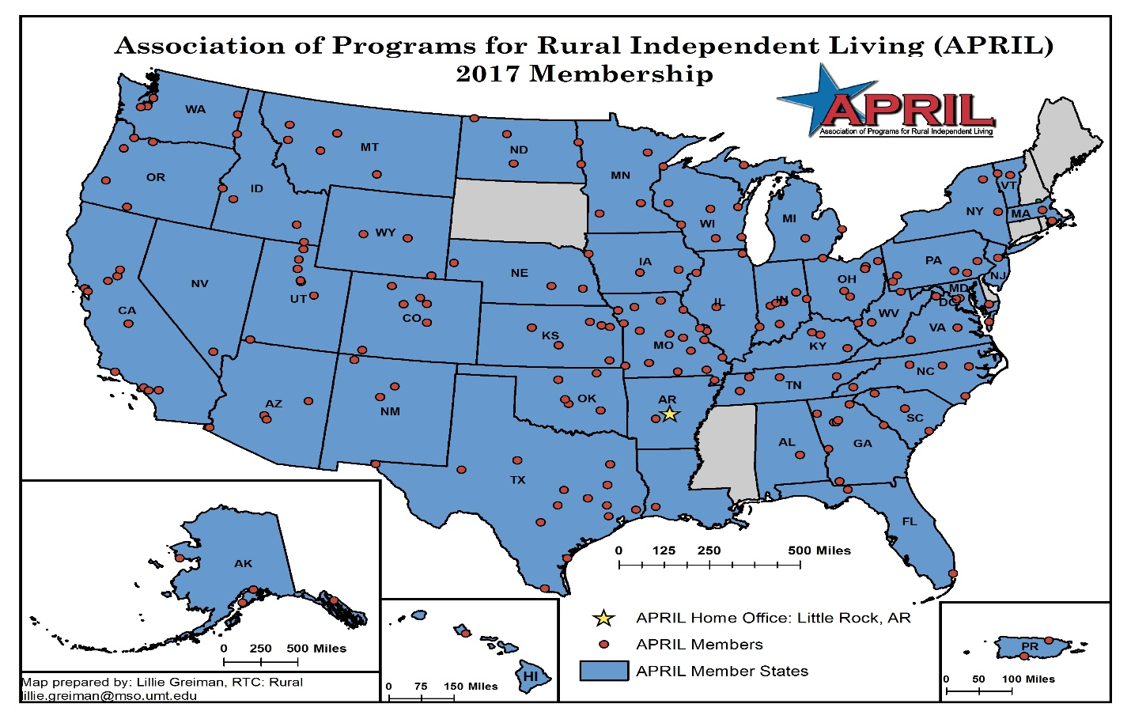
Map of APRIL Members
In 1995, APRIL held its first National Conference on Rural Independent Living in Lawrence, Kansas with a gathering of about 80 participants. Subsequent conferences have reached from Alaska to Puerto Rico; Hawaii to New Hampshire; and numerous points between. And today, attendance numbers have exceeded 400.

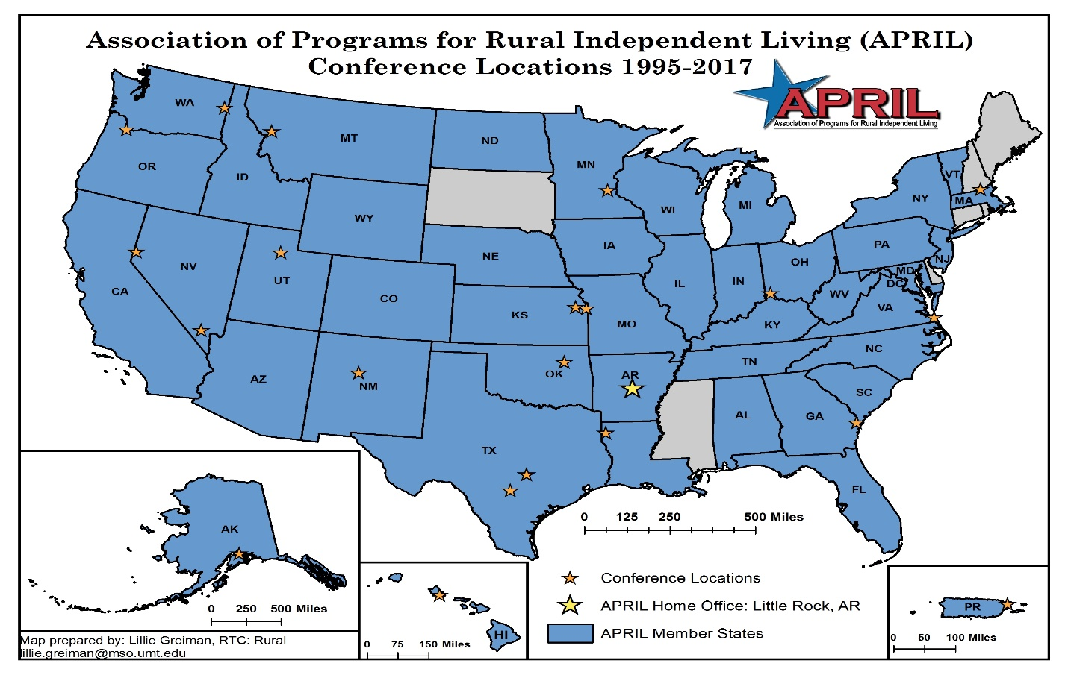
Map of conference sites

In 2001, APRIL was awarded a major grant from the Department of Education to demonstrate a national transportation voucher model for rural consumers with disabilities. With the funding of this project came the development of an infrastructure that would allow APRIL to support phenomenal growth. Staff were hired, policies and procedures were developed and an array of services and fiscal accountability were put in place. In 2008, APRIL collaborated with NCIL and ILRU to form the ILNET.

As a national membership organization, APRIL is dedicated to advancing the rights and responsibilities of people with disabilities in rural America by serving as a center of resources and by leading systems change. We achieve this through our Training and Technical Assistance programs including: our National Conference and Youth Conference, Peer Mentoring programs, Information and Referral, IL Conversation teleconference series, Youth Talk teleconference and facebook chat series, Growing Leadership and Succession Planning workgroup, Knowledge Translation advising, and Dissemination through our list serv and social media. We also achieve our mission with our advocacy and collaboration including: leadership opportunities for youth with disabilities, rural advocacy work groups and initiatives, and our partnerships and work plans with national Research and Training Centers, AgrAbility, and other allied national organizations.

The following are highlights of services and programs offered by APRIL:

Mentoring Program: APRIL Coordinates the IL-NET Peer-to-Peer Mentoring program for Statewide Independent Living Councils and Centers for Independent Living. We currently have 13 Center for Independent Living Directors as regular mentors. We also have three mentors who do limited mentoring’s that fit their skill set. We also have four SILC directors as mentors. APRIL actively seeks out new mentors who are leaders in the Independent Living community. A mentoring is an eight month contract between the CIL or SILC requesting technical assistance services and the mentor who has the best skill set to meet their specific goals. Technical Assistance recipients may be requesting mentoring because they are new to their position or need refreshing on the basics of running an IL organization; or they are looking to expand their organizations typical services or goals and looking for tools, support, and practical advice on moving forward. These mentoring’s are structured either as (1) a reverse mentoring, where the applicant can travel to a mentor’s site to learn from the entire team to see how an IL Center or SILC operates, or (2) a mentoring where the mentor travels to the applicant’s site for a two day training to work with their staff and/or board, or through electronic means. The applicant sets tangible goals with clear expectations for both parties and those goals determine which mentoring method fits best with the preference of the applicant. These mentorings also help inform trends in the needs of the Independent Living Field staff for future training and technical assistance options.

IL Conversations: APRIL Coordinates and hosts the IL-NET teleconference series IL Conversations. These are 90 minute teleconferences that are free of charge to participants and are provided afterword as archived materials, transcripts, and recording on the APRIL website. These provide training on a topic of interest typically focused on CILS or SILCS as well as opportunity for peer support including a conversation surrounding emerging and accepted practices in the IL field around the specific training topic. Past Conversation topics have included VA Overview of Services and Veteran’s Culture, Outreach to Native Americans and Latinos, Discussing Fee for Services, Inclusion of Youth with Disabilities, Creative transportation solutions and services, housing related topics, nursing home transition and diversion, etc. The line-up of training topics is based upon trends in requested Peer-Mentoring Services and our other Training and Technical Assistance programs. We also use Survey Gizmo for survey needs assessing, training series evaluation information, and discussions with staff in the field to fine tune our training line-ups to continue to meet the changing needs.

Annual APRIL Conference: The Annual APRIL Conference is a two and a half day training opportunity that occurs in different locations throughout the country each year. Attendance is approximately 350 participants. The conference typically includes a preconference for a day long in depth training on a topic of interest in the field such as Incorporating Multimedia and Social Media in your CIL or IL Skills Training and your organization; Management skills for Non-Profits, etc. there are also five Keynote sessions that address the entire conference on topics that affect the entire group such as Policy and Administration changes, Advocacy updates, etc. There are also five blocks of concurrent workshop sessions that typically have about six workshops per block. Each block includes workshops on: a youth track which incorporates a youth engaging topic of interest, accepted and emerging practice workshops presented by peer experts in the field, research findings and opportunities for collaboration, tools and training for direct service staff, and training for SILCs and Board members.

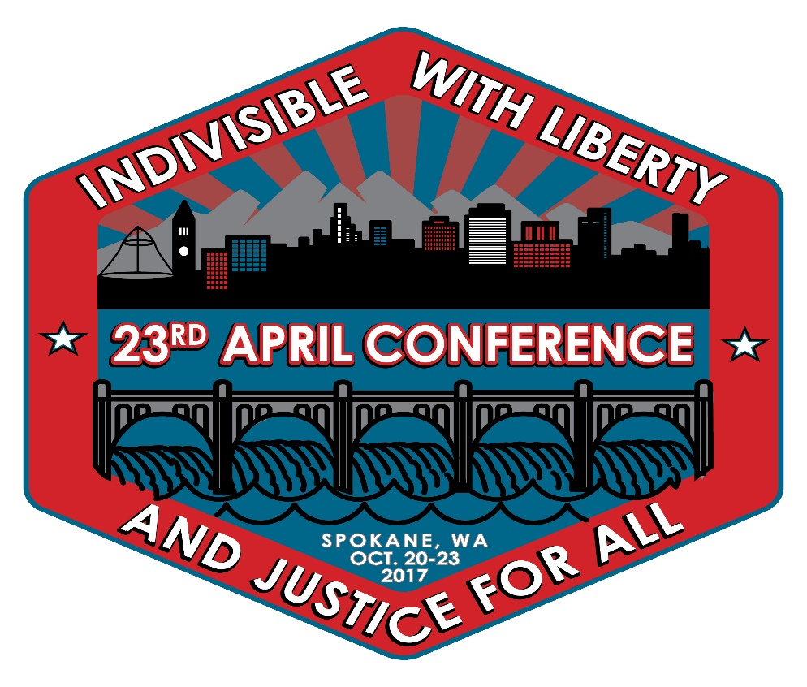
2017 conference logo

Healthy Community Living: APRIL contracts with the RTC:Rural at the University of Montana on the Healthy Community Living project. APRIL runs contracts, relations, and training and technical assistance for eight CILS who are assisting us in an iterative participatory curriculum development for two multimedia curriculums; one of which is an adaptation of Living Well in the Community and the other is writing a new Il Skills training curriculum called Community Living Skills for those who are not quite ready to set goals and complete them but are looking for more basic skills and trying to move along the intrinsic motivation scale to increase self-determination. The Director of Training and TA for APRIL is also responsible as the lead writer for the sessions on Disability Identity, Peer Support, Self-Advocacy, and Transportation as well as editor and team writer for the other sessions on Self-Care, Technical Skills, Healthy Relationships, Budgeting and Financing, Time Management and organization, and Housing. APRIL also is assisting the RTC on creating a photo bank of real people in real places for this project. It can be found at the Flickr channel for Healthy Community Living https://www.flickr.com/groups/healthycommunityliving. All the photos are free to use by anyone in efforts to create real images of people with disabilities. We are also always seeking contributors.

Youth Specific Services

Target populations: Youth Programs Staff at CILS, SILCS, VR, YLF, and allied organizations; Youth with Disabilities; Centers for Independent Living staff, boards, volunteers, and consumers; State Independent Living Council staff and members; Research and Training Centers; other Allied organizations and Community programs such as social workers, nurses, transportation, schools, etc.

Annual Youth Conference- The Annual APRIL Youth Conference, an all-day youth conference event for youth with disabilities ages 30 (ish) and under, is held annually in different locations around the country in conjunction with the Annual APRIL Conference. It has been running for the past 11 years, with attendees steadily reaching 80+. The target population is youth with disabilities who are consumers of CILS, youth staff or volunteers at CILS, or other affiliations, SILC affiliates or board members, Youth Leadership Forum attendees and staff, and rural youth with disabilities who may not yet be associated with Independent Living who are reached through schools, Vocational Rehabilitation, Social Service agencies and other outreach attempts.

The conference was in response to a desire and need from youth with disabilities to have a place to build their community, share their experiences, and learn skills separate from those that were being taught in the main conference to independent living (IL) professionals because some of the barriers and issues facing young rural people with disabilities differed. Some of these barriers include a sense of self and belonging in the disability community, confidence and self-advocacy skills to overcome barriers and reach individual goals, and building a community of support to combat isolation that often comes along with living in a rural area.
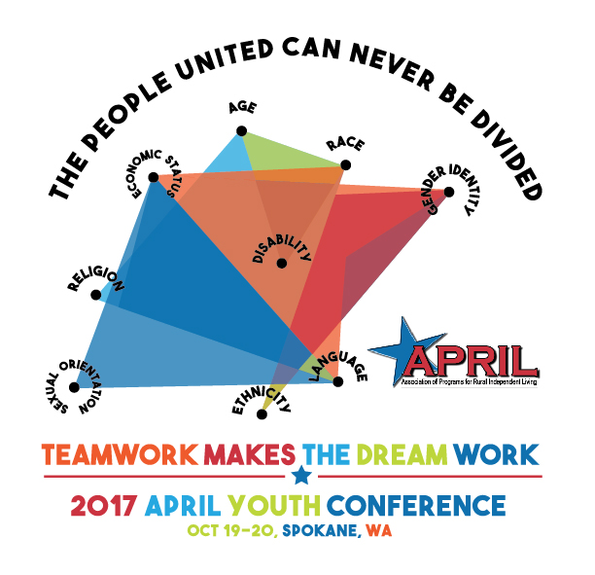
2017 APRIL Youth Conference Logo

For many young people, it is a life changing experience to see an entire conference full of people with disabilities who are professionals and living independently. Many have an opportunity to travel away from home for the first time and gain confidence in their abilities to take control of their lives. The day long youth conference teaches sessions on standing up for yourself, how to make change in your community, what are your rights as a person with a disability, disability history, culture, identity, and current topics that effect their lives. The conference is planned and executed by a committee of volunteer youth with disabilities leaders that have attended in years prior.

Monthly Youth Advocacy Committee Calls- Step 2 in our leadership opportunities. The youth advocacy committee is a monthly teleconference and multi-media opportunity to get involved with other young leaders across the country to impact communities and increase inclusion of people with disabilities. It includes continued skill building, current event discussions, as well as peer support and technical assistance to achieve change in youth's individual communities. Youth lead the discussions, decide the topics we provide training on, and the current event issues that we act upon. APRIL supports by developing tools, such as surveys for needs assessing youth with disabilities in their communities, and technical assistance such as interpreting them. APRIL also provides training surrounding the topics of interest identified by the youth as well as access to current events and interpreting laws and other information. Open to youth with disabilities and allies, especially those who have attended an APRIL Youth Conference in the past.

Advocacy Webinar Training Series: A training series targeted to the members of the youth advocacy committee including finding your voice and your issue, and how to engage in advocacy.

Youth Talk Topical Trainings Series: These are calls held every month on advanced topics affecting those who work with youth with disabilities. They are all presented by our youth mentoring program mentors. These are folks currently working in youth programs or who have worked in youth programs in Centers for Independent Living. This year’s lineup includes: intersectionality, cross-disability inclusion, fee for service in youth programs, building a curriculum, supervising and growing opportunities for youth with disabilities, teaching healthy relationships, and making existing programs youth inclusive. There is a $25 charge to participate on this call, however, CILS who are currently receiving mentoring services through our youth mentoring program can attend these calls free of charge.

SILC Mentoring Work Group- This committee is comprised of SILC staff and council members who have emerging and accepted practices in engaging, mentoring, and encouraging active youth participation on councils. A nationwide survey was used as a needs assessment to identify leaders to join the committee. This committee is creating resources on problem solving for barriers to participation and engagement, peer support and training for council members, as well as tips for engaging young council members in a meaningful way.

Youth Peer to Peer Mentoring Program: APRIL currently has ten youth mentors who are young people who have started or worked in youth programming at a CIL, as well as five other mentors that serve in a capacity to mentor outside of CILS, such as for SILCS to engage youth or to start a Youth Leadership Forum. Mentors work with a mentee for a minimum of six months, including a two day site visit where the mentor visits the site of the mentee to provide onsite training or technical assistance to increase an organizations capacity to serve, employ, and otherwise incorporate youth with disabilities in a multitude of different ways. Mentors, along with several other national youth leaders, have also created a repository for materials that can be used in order to build curriculums or programs to serve youth. These materials that have been borrowed or adapted from CILS and other organizations across the country also contain APRIL unique materials such as Activities that Teach, learning based games, activities, and discussion questions to promote inclusive learning and a teach reteach method of relaying Independent Living concepts to youth with disabilities; strategic planning for your CIL- a strategic planning tool designed to assist an organization to resource map internals and externally and create a work plan for achieving their goals in serving youth, and more. This project is currently only partially funded and relies on the mentee organization to pay for half of the costs. We are currently seeking funding to make this less cost prohibitive to organizations.
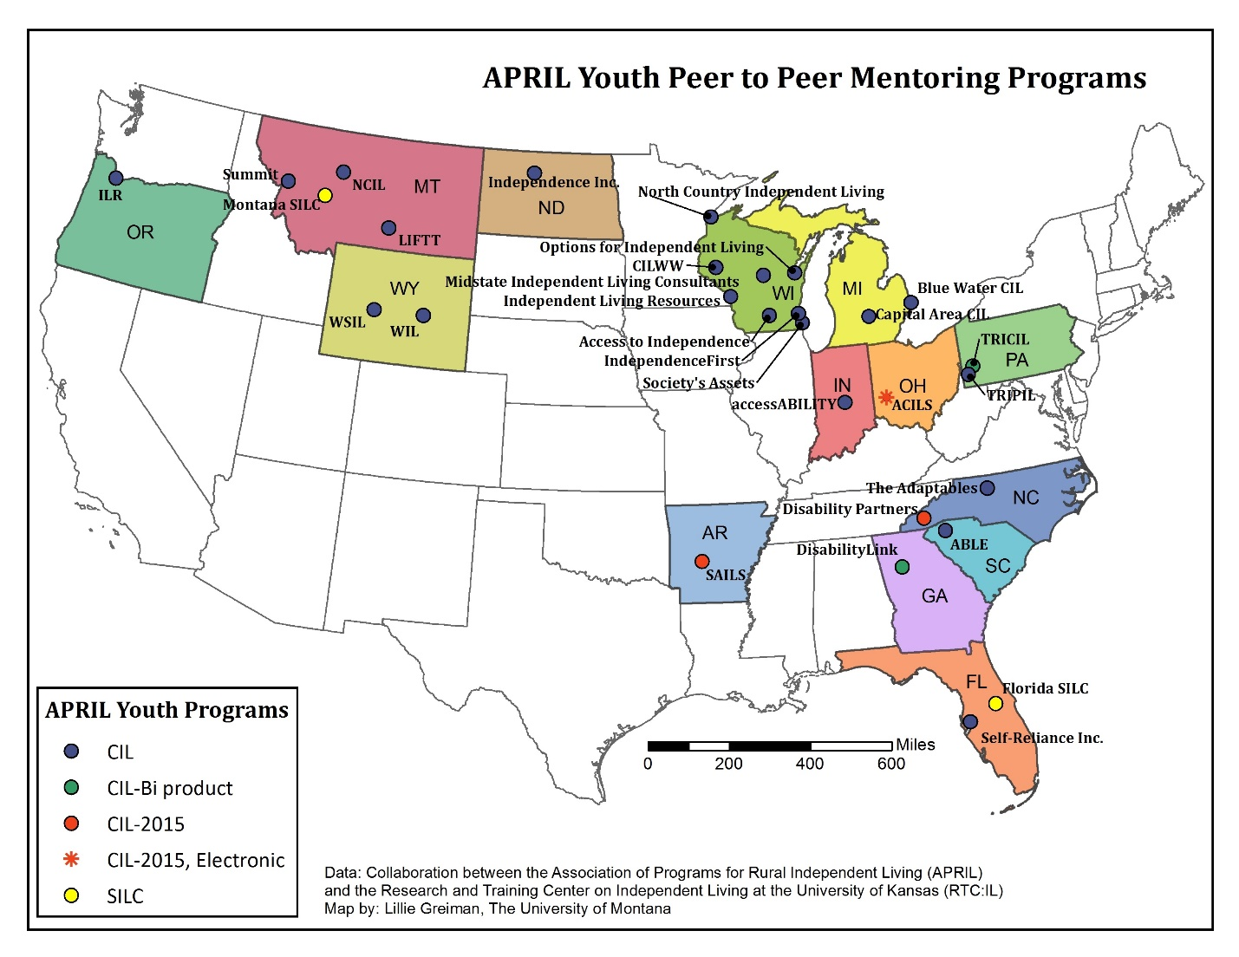
Map of Youth Mentoring Sites

AgrAbility -After years of serving on the National AgrAbility Advisory Team, in 2016, APRIL officially partnered with the National AgrAbility Project. Our partnership works to increase awareness of the National AgrAbility Project and the state funded and affiliated projects in each state with the local CILs and SILCs. We provide resources to APRIL member CILs to assist them in serving farmers and/or ranchers. We are working to increase the opportunities for youth with disabilities that are or want to be involved in agriculture.

Advocacy and strategic collaborations:
AgrAbility National Steering Committee Member
Arkansas Public Transportation Commission (Governor Appointed)
Center of Innovation on Disability and Rehabilitation Research: Advisor
Federal Advisory Committee on Transportation Equity (Appointed by DOT Secretary Foxx)
MT State Independent Living Council Member (Governor Appointment)
National Council on Disability (Presidential Appointment)
National Disability Leadership Alliance Member
National Quality Forum on Home and Community Bases Outcome Measurement (National Advisory Member)
SILC-NET (Facilitator, Trainer, and advisory member)
TCRP B-44 Impact of the Trend Toward Separate Statewide Medicaid Transportation Brokerages on Human Services Transportation Coordination (member)
Transportation Equity Caucus Member

2017 APRIL Funding

