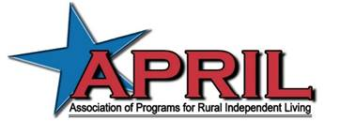

Win a trip to the 2017 APRIL Youth Conference in Spokane, Washington!
- Your submitted design and/or artwork must include the APRIL Youth Conference 2017 tagline, “Teamwork Makes the Dream Work.”
- Every entry must be in a high resolution digital file in .jpg, .png, or .pdf file format.
- ACCESSIBILITY HINT: Designs reproduce best using high contrast and strong colors. These shirts are sold to all attendees so please be sure to make your design gender-neutral.
- Participants must be between the age of 16 and 30.
- Each entry must be an original design. The entry must not be plagiarized or use symbols/pictures that are copyrighted without permission.
- Each entry is due by 11:59 p.m., CST on Sunday, July 19. Please submit your entry together with your Name, Age, Address, Phone Number, and E-mail Address to gheffelfinger@independencefirst.org.
- T-shirt designs will be judged by the 2017 APRIL Youth Executive Committee and winner will be announced on the anniversary of the ADA – July 26.

Deadline: Sunday, July 19, 11:59 p.m. CST

To submit a design/logo for the shirts, please send to: Grant Heffelfinger, APRIL Youth Social Media Liaison, at gheffelfinger@independencefirst.org.

*The winning designer will receive a full scholarship (including lodging and hotel registration) to the 2017 APRIL Youth Conference and APRIL Conference in Spokane, WA on October 20 – 22!

