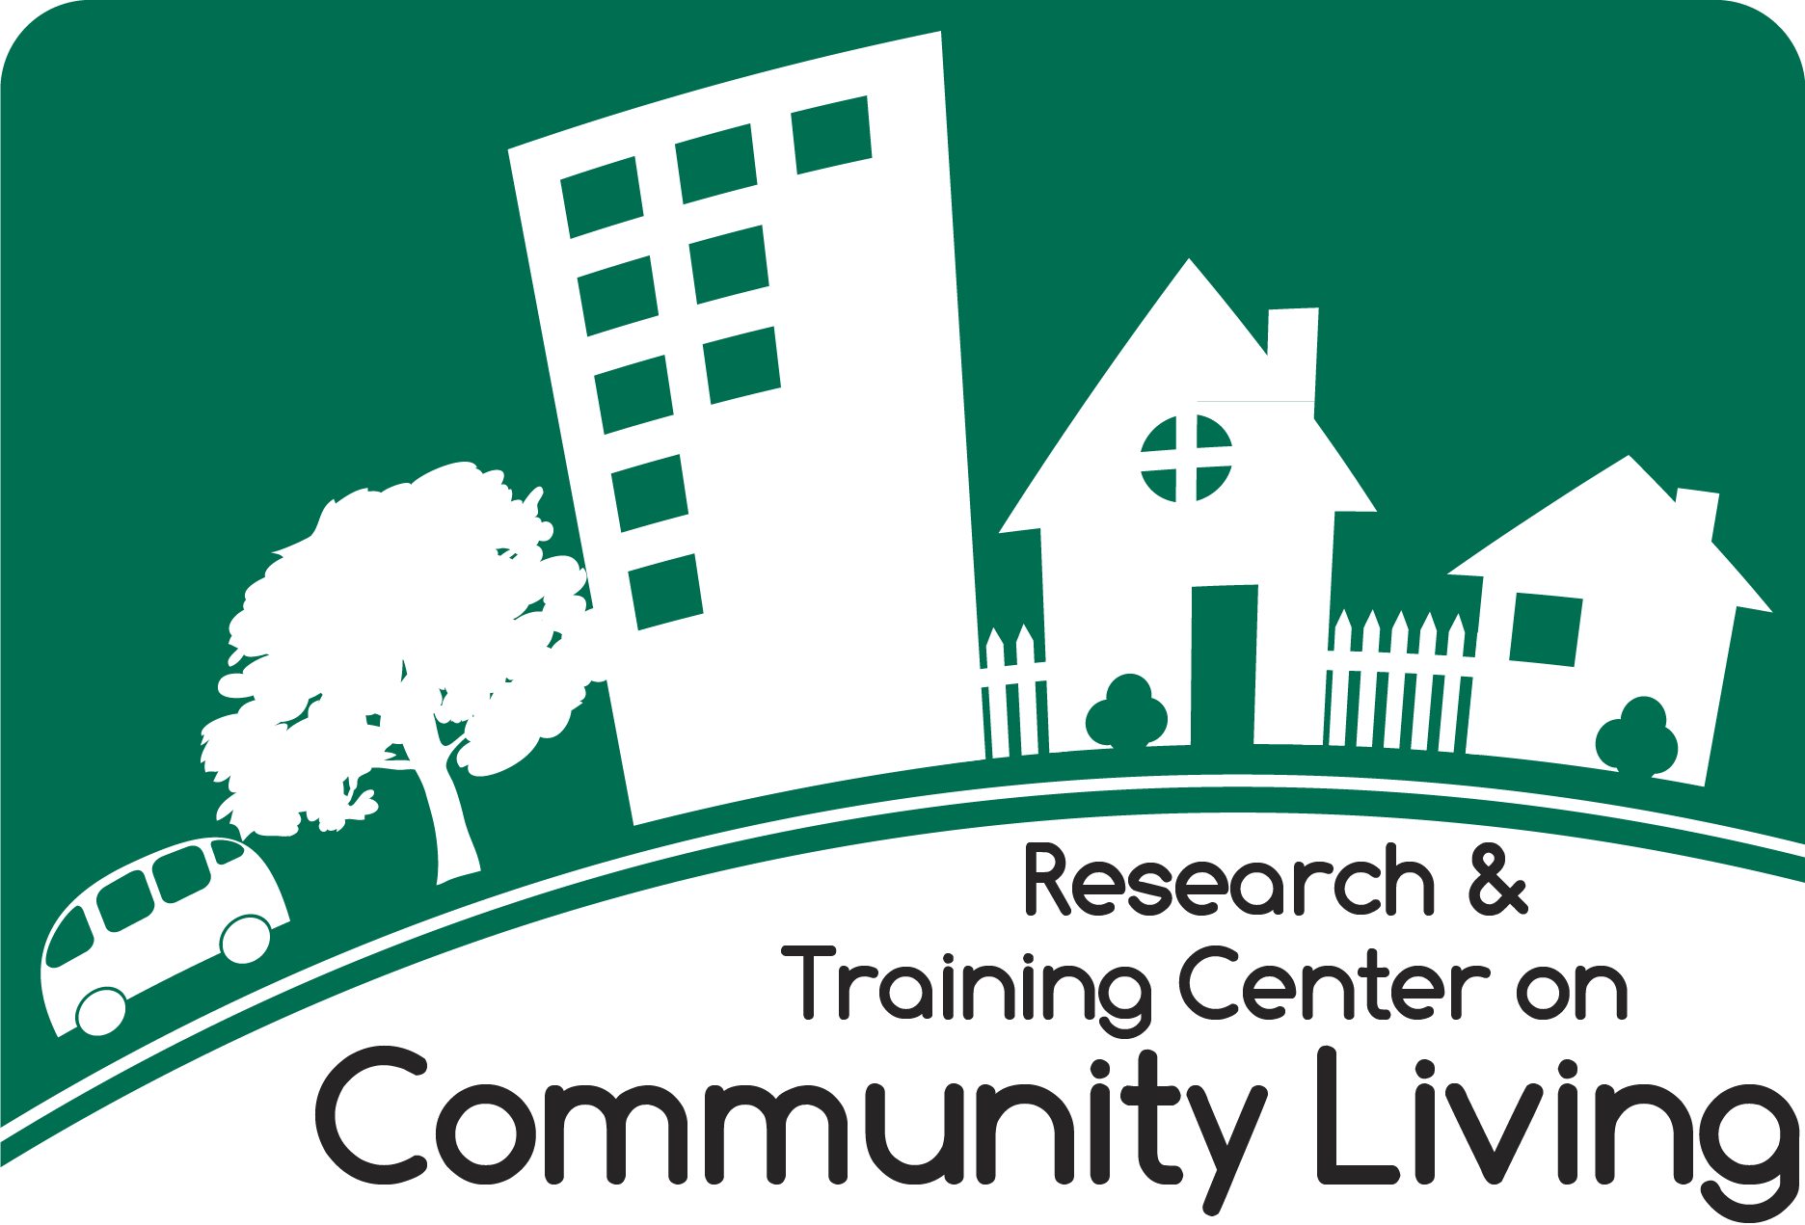
Building Capacity for Full Community Participation:
Promoting and Documenting Changes in Programs, Practices, and Policies
Introduction
People with disabilities are one of the fastest growing minority populations in the U.S. (Institute of Medicine, 2003; Murray, et al., 2013; Nafukkho, Roessler, & Kacirek, 2010). Laws such as the Rehabilitation Act of 1973, Fair Housing Amendments Act of 1988, The Olmstead Decision, and the Americans with Disabilities Act of 1990 were implemented to help people with disabilities move out of institutions, live more independently in the community, engage in the workforce, and live fulfilled lives. Despite these laws and increases in the quantity and quality of independent living support services, people with disabilities still encounter barriers that negatively affect their participation in community life (Hammel, Jones, Gossett, & Morgan, 2015; Kessler Foundation, 2010; Murray et al., 2013; Noreau & Boschen, 2010; White, Simpson, Gonda, Ravesloot, & Coble, 2010; Rimmer & Marques, 2012; WHO, 2011).
Under these laws, Centers for Independent Living were developed to provide services to empower consumers and promote independent living; however, people with disabilities still report that they face barriers to full community participation and limited access to transportation, recreation, education, and employment opportunities (Hammel, et al., 2015; Kaye, Jans, & Jones, 2011; Myers & Ravelsoot, 2016; Newman, 2010; Rimmer & Marques, 2012; Shields, Synnot, & Barr, 2012; White et al., 2010). They may face difficulties transitioning from institutional settings to independent living in the community because of a lack of long-term support services. Even in community settings, people with disabilities may have difficulty leaving their residences and accessing sufficent services to faciliate their engagement in the community (e.g., transportation, recreation, accessible buildings) (Gallagher, O’Donovan, Doyle, & Desmond, 2011; Greiman & Ravelsoot, 2016; Jans, Kaye, & Jones, 2012; Myers & Ravelsoot, 2016; White et al., 2010). Several recent national surveys show significant community participation disparities between people with and without disabilities. For example, only 21% of adults with disabilities ages 18-64 had full or part-time employment compared to 59% of the non-disabled population. Another poll found that of the approximately 31% of students with disabilities enrolled in post-secondary education, only 13% completed their degree. Furthermore, people with disabilities reported less satisfaction with levels of community participation and reported higher spending on medical and health-related issues than their non-disabled peers. These data suggest that consumers with disabilities still face significant barriers to increasing and maintaining community participation and living independently (Hammel, et al., 2015; Harris Interactive, 2010; Murray et al., 2013; Reichard, Stolze, & Fox, 2011).
What can be done to support participation of people with disabilities in their communities? Since the late 1970’s, Centers for Independent Living (CILs) have played an important role by promoting community participation and independent living (IL) skills for people with disabilities. This is accomplished in part by providing core independent living supports in five service areas, including: self-advocacy, peer counseling, IL skills training, information and referral, and transition (Ravesloot, White, & Gonda, 2010). One way to enhance community participation is to equip CILs with tools to improve their organizational and community-capacity building competencies (Woods, Watson-Thompson, et al, 2014; Fawcett, Schultz, et al., 2013). Improving these competencies can benefit the center and consumer with disabilities full community participation. For example, organizational and community-capacity building of CILs and community partners may improve the quality of CIL and community programs and services provided leading to fuller participation in the community. Additionally, CILs may benefit from capacity building by increasing the number of organizations with which they collaborate extending their channels of influence in the community (Thompson, Fawcett, & Schultz, 2008a).
There is evidence that the community also benefits from CILs community capacity-building activities. In the broadest sense, community capacity building can enhance a community’s “social capital” by including and engaging consumers in the community through volunteering, serving on non-profit boards and civic activities such as voting (Jacobson, Azzam, & Baez, 2013; Rimmerman, 2013; Vornholt, Uitdewilligen, Nijhuis, 2013).
The purpose of this exploratory research project was to examine the effects of training to enhance core competencies (i.e., assessing community needs and resources, analyzing problems and goals, developing strategic and action plans, developing an intervention, increasing participation and membership and advocating for change) and providing technical assistance to participating CILs in federal regions VI and VII. The intent of the training and technical assistance was to enhance community accomplishments, ultimately leading to improved outcomes for people with disabilities. The project also investigated the contextual and influencing factors that distinguished CILs’ ability to successfully implement community changes promoting full participation. The project taught partnering CILs how to systematically document their accomplishments in an online monitoring and evaluation system, the Community Check Box (CCB). The CILs utilized this data to help assess their progress and adjust their performance.
Methods
Researchers recruited Centers for Independent Living (CILs) from central and southern Midwestern states across Regions VI and VII. An announcement was issued inviting CILs to apply to participate in this project, and 12 CILs were chosen to participate (9 ultimately completed the project). A multiple baseline staggered implementation was employed. Each CIL was randomly assigned to one of three groups, and implementation was staggered across the three groups. All participating CILs began collecting baseline data three months prior to the training for the first cohort of CILs. The second cohort received training six months following cohort 1, and the third cohort received training 12 months following cohort 1.
Implementation of the intervention consisted of in-person training followed by ongoing monthly technical assistance. Interactive training was provided to two staff members from each participating CIL during a three-day workshop consisting of lectures, small group discussion, and real-life application with the goal of building capacity for collaborative action in communities. Training topics were selected based on input from attendees at the 2012 National Conference on Independent Living, and included six of the sixteen core competencies in the Community Tool Box Curriculum (http://ctb.ku.edu/en/training-curriculum), adapted with examples for the independent living context. Training topics included:
- Assessing Community Needs and Resources – Listening to community members and what matters to them; methods for gathering information about community needs and assets for improvement
- Analyzing Problems and Goals - Conducting a thorough analysis of the community problem(s) and goal(s) that the effort will address, including analysis of key behaviors, personal and environmental factors, targets and agents of change, and potential solutions
- Developing Action Plans - Importance of developing strategies and action plans and using them to guide the work; Skills required to develop a vision, mission, objectives, strategies and action plans
- Developing an Intervention - Skills required to develop, select, adapt and implement interventions to fit the particular needs and cultural context of your community
- Increasing Participation - Why it is crucial to intentionally involve others in the work, and engage them in ways that keep them involved over time; Key principles in outreach and recruitment
- Advocating for Change - Guidelines for effective advocacy; Advocacy techniques of varying intensity, and how potential advocacy tactics can help achieve goals
Technical assistance and peer mentoring were provided each month following training during conference calls for each cohort. These calls occurred monthly for the duration of the project. CILs discussed progress taking action and implementing community changes to create opportunities for consumer community participation. CIL staff members also discussed challenges encountered, promising practices that might be implemented, and participant-generated solutions to facilitate increased community participation. Researchers initiated action planning meetings with participating CIL staff at the mid-point of the project to review and update targeted community actions and community changes to be sought. The technical assistance calls periodically incorporated subject matter experts who addressed topics of interest, such as measuring community usability and housing accessibility.
Documentation of CILs’ efforts was conducted using the online Community Check Box (CCB) Evaluation System. Designated CIL staff members logged their CIL’s efforts to change their communities in ways that promoted full participation for people with disabilities. Using graphs and lists of accomplishments generated by support staff using the CCB, the CILs’ efforts were periodically reviewed individually with participants as well as during TA teleconferences to develop an understanding of the activities contributing to these efforts, the context for the work, and possible adjustments to the work to increase success.
Training on documenting activities using the CCB was provided to the CILs by the KU research team. Using the CCB, the CIL staff: a) entered their activities and accomplishments; b) coded instances of development activities, services provided, community actions to bring about community changes, and the new or modified programs and policies that constitute community change; and c) they characterized accomplishments for key attributes, including the behavior change strategy used, duration or the length of time and frequency of the change, and number of people reached. The KU research team calculated the intensity score for each community change in order to measure and communicate its contribution to the improvement of full participation in the community. A numerical value was assigned to the strategy, duration, and reach of each community change. These values were summed to obtain a single intensity score for each new or modified program or policy. Intensity scores for each program or policy were then summed for form a total community intensity score, for all of the programs and policies in place prior to training and for those in place after training. These results were used only by researchers for analysis of the results of the study.
Researchers conducted interviews with CIL staff to identify key events that may have affected the implementation of community changes. Challenges that made implementing community changes more difficult and facilitating conditions that made community change implementation more likely were also collected.
Results
The project sought to increase community actions and changes that would increase participation for citizens with disabilities. All the community changes (i.e., new programs, policies and practices) implemented by the participating CILs are displayed in a cumulative form in Figure 1. The participating CILs implemented a total of 1971 community changes from August 2012 to April 2016. In the following figure, a cumulative line in which new community changes are added to the previous changes over time shows the implementation of new programs, policies and practices for all CILs during that time. Key events reported by CILs as affecting their efforts are noted on the graph as well.

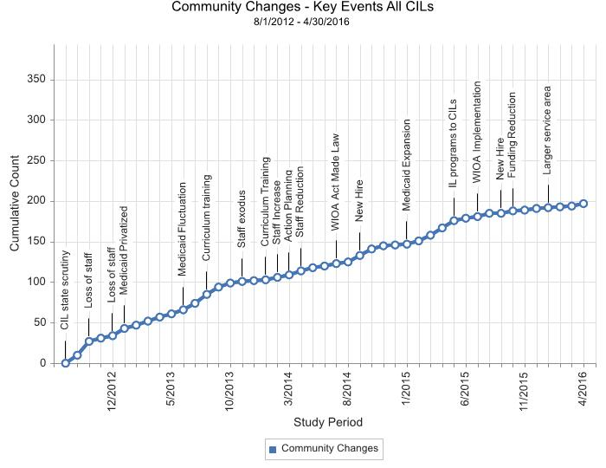
Curriculum Training

Categories of behavior change strategies and examples of changes identified by the CILs include: a) providing information - presentation at “lunch and learn” to case managers at the Area Office on Aging to provide education on the value of independent living; b) enhancing services and support - launched new low-vision support group in the community; c) improving skills - new pre-employment transition skills training provided to students returning to high school including driver's education, attitude and behaviors, and budgeting to help increase success in community employment; e) changing consequences - provide vouchers for apartment complexes to help residents with disabilities afford housing; d) modifying access, barriers, and opportunities - Day of Caring Ramps Project event involving citizens building ramps for veterans with disabilities; and f) creating policy - legislation passed that transferred the state's IL Services program to state CILs.
Achieving full community participation for people with disabilities requires that communities and systems reduce barriers to inclusion. Participating CILs implemented community changes across a wide range of full participation goals and targeted goals based on the needs and interests of constituents. This is where the science and art of community action takes place.
Community Change Graph

Of the 197 community changes implemented, 21 of the 23 full participation goals (e.g., access to education, access to services, advocacy, civic engagement, employment, housing, pain management, peer support, transportation) were targeted. Goals addressed by accomplishments included access to services (16%), advocacy (10%), independent living skills (10%), accessibility to public places (6%) and peer support (6%). No accomplishments were reported as primarily targeting mental health and pain management goals. The remaining goals received 1% to 5% of the changes brought about by the CILs. Most of the highly targeted goals are in line with the mandated CIL services.
Did CILs improve their capacity to bring about community and systems changes with training and technical assistance? While some of the CILs had increased rates of community change following training, there was improvement in the quality of community changes implemented. The quality measure is an intensity score that was developed for each community change. Each community change was weighted by the length of time people might be exposed to the program or policy (i.e., duration), the strength of the strategy used by the community change to change behaviors in the community (e.g., was it only information provided, or was it a stronger policy change?), and the potential number of people it reached (i.e., the more reached by the program or policy the stronger it was). Four of the nine participating CILs increased the intensity score of the community changes implemented after the initial training. Though this was not statistically significant, some components of the intensity score, such as the type of strategy used, did show significant improvement. This suggests that CILs were more likely to implement strategies that were in high impact categories such as modifying access, barriers, and opportunities or strengthening policies than simply providing education or skills training, which have less widespread effect on people’s behavior. Strategies have higher impact when they focus on environmental conditions and less on individual risk and protective factors.
Other factors contributed to Centers’ ability to change communities. What organizational factors might have affected their capacity to support change? What context features at the community, state and federal level inhibit or facilitate CILs’ efforts to change the community in ways that improve the lives of people with disabilities? Researchers, CIL partners, and national IL experts and advocates reviewed the results and identified organizational and community contextual factors that contributed to or hindered CIL ability to implement change between 2012 and 2016. They were asked to identify the factors which affected Center efforts during this time period. Key events that facilitated changes or presented challenges to CILs’ ability to make changes in communities and outcomes are presented in Figure 1. These included changes in leadership, loss of funding, and loss of staff.
Discussion
Several of these challenges are presented below:
- Staff changes and leadership
Changes in staffing affected CILs’ capacity to bring about community change. The addition of staff enabled the CILs to bring about new programs and policies; loss of staff limited their ability to do so. Data show that losses in staff occurred more frequently and had a greater impact on CILs’ capacity for change. “Smithville CIL” experienced a significant loss of employees described by staff as an “exodus,” including the loss of several directors during a one-year period. Staff time available to bring about community change suffered as the remaining employees struggled to maintain core services.
- Medicaid expansion (or not)
State-level changes due to rejection of Medicaid expansion reduced funding for CIL services. Services such as case management were in some cases shifted from CILs to other organizations/ managed care organizations. In addition, states that engaged in aggressive reductions in state spending scrutinized and carefully reviewed spending by the CILs, leading them to become more risk-averse. Fewer community actions were taken as the focus narrowed to maintaining their ability to provide direct IL services. CILs responded to this threat by engaging communities through public education, awareness building, and voter registration.
The health insurance requirements of the Affordable Care Act often led to extremely high caseloads and consumer demands for navigation assistance limited CILs’ ability to focus on new community programs and policies. Other state requirements, from Vocational Rehabilitation for example, concerning eligibility of consumers for IL support led to the loss of consumers of other IL services. Loss in funding preceded declines in implementation of community change.
- WIOA Law Enacted
The Workforce Innovation and Opportunity Act (WIOA) was enacted in July 2014, with requirements for implementation taking place in July 2015. WIOA transferred independent living programs from the Department of Education to the Administration for Community Living within the Department of Health and Human Services. The enactment of WIOA led to some CILs increasing community changes, including by promoting voting registration efforts and disability awareness events in schools and the community. CILs are required to provide transition services (both to youth transition and from those in institutions back to community living). This new core service is required but not yet funded.
- Funding
Funding influenced CIL capacity for community change directly and indirectly. Loss of funding was a huge challenge. However, when CILs obtained grants and other sources of funding, even small grants, they were able to bring about more community change. Some states even restricted CILs efforts to seek new or more funding. Over time, CILs obtained some new contracts and grants, but were overwhelmed by other losses.
- New initiatives or expanded services area
Some small new grants expanded CIL services in new areas. However, increased geographic coverage often stretched staff because the increase in funding was not proportional to the increase in responsibility for a larger service area. Especially among rural CILs, limited staff covering expansive geographic areas is challenging and limits time for engaging in community action.
- Organizational changes
Significant organizational changes were taking place in some of the CILs when the project started. For example, consolidation of facilities and sites due to challenges in sustaining former levels of services in multiple sites. Organizational structure may also have influenced community action. In some CILs a collaborative staff structure lent itself to more efficient service provision. Others set goals to raise awareness of services and mobilize consumers. CIL involvement in community-level sector-specific working and planning committees extended their reach and influence in the community. Some CILs had the potential capacity to implement more community change. However, time spent on community change competes with time spent on incentivized direct services, resulting in a more limited focus on community mobilization and change.
Lessons learned:
The lessons learned from the Building Capacity for Full Community Participation Project are compiled from qualitative follow-up interviews with participating CILs during the project. The purpose of the lessons learned for the Building Capacity for Full Community Participation Project is to provide them for use by other centers in the future. The lessons learned from this project are tips that might be used by CIL staff and leaders as they adapt their organizations to changing conditions.
- Use participatory assessments of needs, challenges and barriers to focus implementation of community changes on the greatest need.
- Review action plans regularly for relevance and renewed vision and motivation
- Build relationships with representatives from organizations in housing, transportation, healthcare and other domains to expand capacity to bring about change.
- Create partnerships that include goals and objectives focused on needed change in those sectors.
- Produce added knowledge through the development of Learning communities
- Develop and use advocacy groups to amplify staff capacity.
- Build on knowledge from the other participating Centers.
- Use informal community intervention pilot project to show potential adopters results
- Provide helpful tips to partners on how programs can be implemented to make uptake easier.
- Find organizations that are early adopters of new programs and use to motivate other groups to take up the community change.
Contextual Considerations
During the study period, CILs engaged in community change efforts in a challenging environment. This longitudinal study offers another viewpoint on how state and federal policies, as well as local influences, affected CIL operations, services and capacity for changing conditions in communities that promote full participation. Collaborative community-wide approaches to remove barriers to full community participation of people with disabilities is a useful strategy to help CIL’s fulfil their mission. Though advocacy is one of the core strategies CILs use to empower consumers, it is limited in its development and implementation.
For CILs to become strong leaders in changing community conditions requires greater capacity and renewed focus on community-level change. Under the right conditions, building the capacity of CILs and their community partners can lead to greater community change. Collaborative community change can lead to more engagement of people with disabilities in the community. Current state-level funding cutbacks and national changes supporting health care have diminished CILs’ current capacity to facilitate community change.
Reduced safety nets lead to increased caseloads and consumer demands. CILs are required to compete with other larger managed care organizations. Governmental and funding agencies have a limited understanding of the unintended consequences that affect CILs and their ability to focus on needed community and systems change. CILs refocus their efforts on managing staff reductions while trying to respond to greater consumer demands; on increasing direct service that is reimbursable, reinforcing an already predominately direct service orientation; and reducing their efforts, due to perceived difficulty, to bring about community change.
Who can lead the charge for change during a period of fiscal contraction, needed and improved levels of governmental oversight, legislative mandates, changing reimbursement requirements, and downsizing? Though there were some successes, this study showed CILs’ limited ability to bring about the community change needed to reduce the isolation of people with disabilities during times of significant political and fiscal upheaval. It does suggest that in order to refocus and increase CILs’ ability to create a community landscape that enhances full community participation will require greater capacity, changed community and state conditions, and renewed community willingness to take action.
Recommendations based on this study’s findings promote CIL capacity to enhance their capacity to change conditions for people with disabilities in the communities they serve.
Recommendations
In order to fulfill NIDLRR’s second mission statement to “Expand society’s capacity to provide full opportunities and accommodations for its citizens with disabilities” CILs should:
- Build staff competencies for community change
- Develop and support collaborative action partnerships
- Implement action plans developed by community partnerships.
- Provide leadership and facilitate comprehensive multisector efforts
- Offer seed resources to stimulate community change
- Document and evaluate community change efforts

References
Fawcett, S. B., Schultz, J. A., Holt, C. M., Collie-Akers, V., & Watson-Thompson, J. (2013). Participatory research and capacity building for community health and development. Journal of prevention & intervention in the community, 41(3), 139-141.
Gallagher, P., O’Donovan, M. A., Doyle, A., & Desmond, D. (2011). Environmental barriers, activity limitations and participation restrictions experienced by people with major limb amputation. Prosthetics and orthotics international, 35(3), 278-284.
Greiman, L., & Ravesloot, C. (2016). Housing characteristics of households with wheeled mobility device users from the American Housing Survey: do people live in homes that facilitate community participation? Community Development, 47(1), 63-74.
Hammel, J., Jones, R., Gossett, A., & Morgan, E. (2015). Examining barriers and supports to community living and participation after a stroke from a participatory action research approach. Topics in Stroke Rehabilitation.
Harris Interactive. Survey of employment of Americans with disabilities. New York, NY: Kessler Foundation and National Organization on Disability, 2010.
Institute of Medicine. Community. In: Medicine Io, editor. The future of the public’s Health in the 21st century. Washington, D.C.: National Academies Press; 2003. p. 178-211.
Jacobson, M. R., Azzam, T., & Baez, J. G. (2013). The nature and frequency of inclusion of people with disabilities in program evaluation. American Journal of Evaluation, 34(1), 23-44.
Jans, L. H., Kaye, H. S., & Jones, E. C. (2012). Getting hired: successfully employed people with disabilities offer advice on disclosure, interviewing, and job search. Journal of occupational rehabilitation, 22(2), 155-165.
Kaye, H. S., Jans, L. H., & Jones, E. C. (2011). Why don’t employers hire and retain workers with disabilities? Journal of occupational rehabilitation, 21(4), 526-536.\
Kessler Foundation & National Organization on Disability. The ADA 20 years later: The Kessler Foundation/NOD 2010 Survey of Americans with Disabilities. 2010.
Myers, A., & Ravesloot, C. (2016). Navigating time and space: how Americans with disabilities use time and transportation. Community Development, 47(1), 75-90.
Murray, C. J., Abraham, J., Ali, M. K., Alvarado, M., Atkinson, C., Baddour, L. M., ... & Bolliger, I. (2013). The state of US health, 1990-2010: burden of diseases, injuries, and risk factors. Jama, 310(6), 591-606.
Nafukho, F. M., Roessler, R. T., & Kacirek, K. (2010). Disability as a diversity factor: Implications for human resource practices. Advances in Developing Human Resources, 12(4), 395-406.
Newman, S. D. (2010). Evidence‐Based Advocacy: Using Photovoice to Identify Barriers and Facilitators to Community Participation After Spinal Cord Injury. Rehabilitation Nursing, 35(2), 47-59.
Noreau, L., & Boschen, K. (2010). Intersection of participation and environmental factors: a complex interactive process. Archives of physical medicine and rehabilitation, 91(9), S44-S53.
Ravesloot, C., White, G., & Gonda, C. (2010). Measuring CIL services that improve community participation for people with disabilities. Disability and Health Journal, 3(2), e8.
Reichard, A., Stolzle, H., & Fox, M.H. (2011). Health Disparities Among Adults with Physical Disabilities or Cognitive Limitations Compared to Individuals with No Disabilities in the United States. Disability and Health Journal, 4(2), 59-67.
Rimmer, J. H., & Marques, A. C. (2012). Physical activity for people with disabilities. The Lancet, 380(9838), 193-195.
Shields, N., Synnot, A. J., & Barr, M. (2012). Perceived barriers and facilitators to physical activity for children with disability: a systematic review. British Journal of Sports Medicine, 46(14), 989-997.
Watson-Thompson, J., Fawcett, S. B., & Schultz, J. A. (2008). Differential effects of strategic planning on community change in two urban neighborhood coalitions. American Journal of community psychology, 42(1-2), 25-38.
White, G. W., Simpson, J.L., Gonda, C., Ravesloot, C. R., & Coble, Z. (2010). From Independence to interdependence: A conceptual model for better understanding community participation of centers for independent living consumers. Journal of Disability Policy Studies, 20(4), 233-240.
World Health Organization. (2011). World report on disability. World Health Organization.
Woods, N. K., Watson-Thompson, J., Schober, D. J., Markt, B., & Fawcett, S. (2014). An Empirical Case Study of the Effects of Training and Technical Assistance on Community Coalition Functioning and Sustainability. Health promotion practice, 15(5), 739-749.
Vornholt, K., Uitdewilligen, S., & Nijhuis, F. J. (2013). Factors affecting the acceptance of people with disabilities at work: a literature review. Journal of occupational rehabilitation, 23(4), 463-475.

